**Dressing Princess**

**Manual**

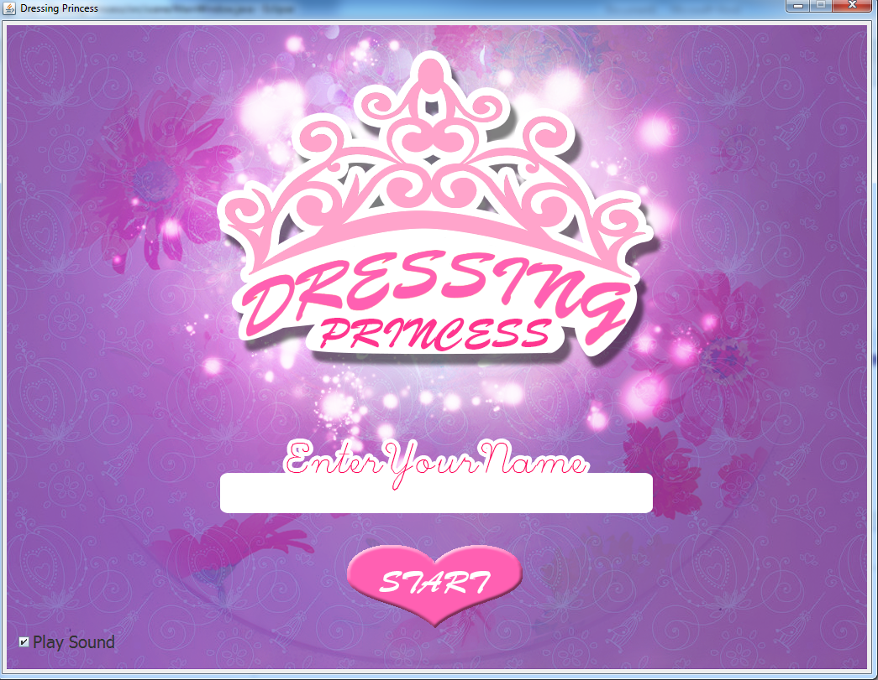

5731083221 - Peerawut Luengruengroj

5731101921 - Sasicha Poonpol

2110215 Programming Methodologies I

Semester 1/2015

Chulalongkorn University

**Dressing Princess**

Description

Dressing Princess is single player game. The player was requested to complete math puzzle and collect score to help princess buy new dress for her marriage. Player has to answer the equations’ answers in the black space within 1 minute. Every right player will get score up to difficultly.

UML Diagram

**Implementation Detail**

1. Class Player

This class contain in package “player”. This class used for keep player data.

1.1 Field

**-** static String name;this field keep player’s name.

- static int score; this field keep player’s total score. The default value of this field is 0.

1.2 Method

+ static int getScore(); return player’s total score.

+ static void addScore(int score); add player’s score.

+ static String getPlayerName(); return player’s name.

+ static void setPlayerName(String name); set player’s name.

2. Class GameManager

This class contain in package “manager”. This class used for manage every scene in game.

2.1 Method

+ static void newGame(); use for create prologue, add prologue to game’s frame and play prologue’s slideshow.

+ static void runGame(); use for create game’s main map and add to game’s frame.

+ static void runMiniGame(); use for create mini game scene and add to game’s frame.

+ static void playGame(String mode); use for create mini game’s playing scene and add to game’s frame. This method used to start mini game too.

+ static void gameOver(int total); use for create game over scene after ending mini game and add to game’s frame.

+ static void gotoShop(); use for create shop scene and add to game’s frame.

+ static void endgame(); use for create ending scene when player buy dress successfully and add to game’s frame. This method also plays ending scene slideshow.

+ static JButton createButton(BufferedImage icon); used for create jButton with icon from BufferedImage. Also make this JButton’s background translucent and borderless.

3. Class RandomUtility

This class contain in package “manager”. This class is utility for random integer and operand.

3.1 Method

+ static int EasyRandom(); return the random integer from 1 to 10.

+ static int MediumRandom(); return the random integer from 1 to 100.

+ static int HardRandom(); return the random integer from 1 to 1000.

+ static String OpRandom(); return the String of operand (+ or -) which 50% is “+” and other is “-“.

+ static int levelRandom(int level); return the random integer from 1 to level.

4 Class Resource

This class contain in package “manager”. This class used for load BufferedImage and AudioClip. Also, used for play and stop AudioClip.

4.1 Field

- static BufferedImage bg; this field used for contain BufferedImage from Classloader.

- static AudioClip bgm; this field used for contain background music AudioClip (bgm.wav).

4.2 Constructor

Set value to all AudioClip from WAV file as assign in 4.1.

4.3 Method

+ static BufferedImage getBackgroundImage(String directory); return the BufferedImage from certain “directory” path and file.

+ static void getAudio(String directory); return the AudioClip from certain “directory” path and file.

5. Class Setting

This class contain in package “manager”. This class used for contain constant value in game.

5.1 Field

+ static final int screenWidth; contain value of this game’s screen width. The value always be 1024;

+ static final int screeHeight; contain value of this game’s screen height. The value always be 768;

+ static boolean isPlaySound; contain playing sound setting if it’s is true, the game will play sound. If not, the game won’t play sound.

+ static final Font standardFont; contain font pattern. The font style of this field is “Tahoma” font, plain style has size 20.

+ static final Font slimBigFont; contain font pattern. The font style of this field is “Tahoma” font, plain style has size 30.

+ static final Font bigFont; contain font pattern. The font style of this field is “Tahoma” font, bold style has size 40.

6. Class GameTitle

This class contain in package “scene”. This class is JPanel and the picture is look like the Figure 1.



Figure 1. GameTile

6.1 Field

- static final long serialVersionUID; this field is auto generated by compiler, the value is 1L by default. (Provided)

- JTextfield playerName; JTextfield for player to enter his or her name. This field is translucent and borderless. This field place under “Enter Your Name” as Figure 1.

- JCheckbox playSound; JCheckbox which lets player choose to play or not play sound in game.

- JButton startButton; the game starting button. When clicked, it will call GameManage to load prologue. If the “playerName” is blank, It will show dialog to tell people as Figure 2.

- BufferedImage bg; used for contain this panel’s background image.

- BufferedImage button; used for contain “startButton” icon.

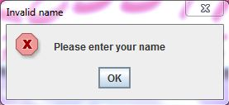

Figure 2. Showed dialog when “playerName” is empty.

6.2 Construction

+ GameTitle(); add component (playerName, playSound, startButton) as Figure 1. As well as load background image and “startButton” icon.

6.3 Method

+ void paintComponent(Graphics g); draw background image to this panel. This method is overriding.